PInniped bycatch in the Barents Sea.

The ICES Fisheries Overview of the Barents Sea Ecoregion (ICES 2019) provides no information on pinniped bycatch rates in the region. However, several publications report sampling and studies of bycatch in the Norwegian coastal gillnet fisheries (Bjørge et al. 2002, 2017, Moan 2016). The coastal catches are entirely of harbour and grey seals. There are no quantitative data on by bycatches of other pinniped species in offshore waters.

Bjørge et al. (2017) report on three separate threads of evidence for the extent of pinniped bycatch in the Norwegian coastal gillnet fishery for cod and monkfish. First was a mark-recapture study involving tags attached to pups in coastal breeding sites between 1997 and 2014 and returned by gillnet fishers. The data indicated a mean annual bycatch of 555 harbour and 466 grey seals for the Norwegian coast north of 62°N. This study built on earlier tagging work (Bjørge et al. 2002) between 1975 and 1998.

The second thread of evidence was the database of fully documented catches taken by the ‘Coastal Reference Fleet’ – a subset of the Norwegian coastal fishing fleet recruited to provide complete information on all species and quantities caught (Figure 1). The reference fleet data were extrapolated to the entire fleet using a variety of co-variate models. The analysis indicated a mean annual bycatch of 479 harbour and 84 grey seals in the period 2006-2014.

The third thread was evidence from modelling studies of of mortality in populations of harbour and grey seals that could nit be explained by any other cause. This analysis indicated a mean annual bycatch of 150 harbour and 80 grey seals.

Bjørge et al. (2017) considered the mark-recapture data to be the most reliable in terms of total numbers, but lacked spatial granularity. On the other hand the results derived from the reference fleet database provided both spatial and temporal resolution.

We used the data from the reference fleet analysis of Bjørge et al. (2017) (Figure 2) to estimate the proportions of “all-Norway” harbour and grey seals caught in statistical areas 03, 04 and 05 (Table 1). All or part of these areas fall within our Barents Sea model domain. We then applied these proportions to the “all-Norway” estimates of bycatch derived from the mark-recapture data (Table 2). Assuming a mean weight per individual in the bycatch of 60kg for harbour seal and 100kg for grey seal (the captured individuals were mainly young-of-the-year), yields a bycatch weight of both species combined in areas 03, 04 and 05 of 17.5 tonnes.

The annual average Norwegian gillnet effort in areas 03, 04 and 05 derived from data provided by the Norwegian Directorate of Fisheries was 94,641 hours. The estimated international gillnet effort within our Barents Sea model domain was 33,489 hours. Hence the estimated bycatch within the model domain was **6.2 tonnes** (Table 3).

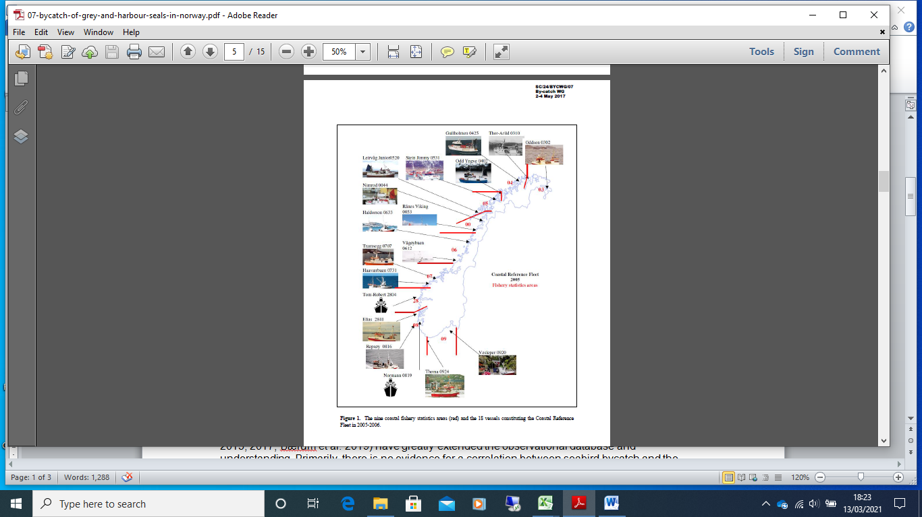

***Figure 1****. Bjørge et al. (2017) Figure 1. The nine coastal fishery statistics areas (red) and the 18 vessels constituting the Coastal Reference Fleet in 2005-2006.*

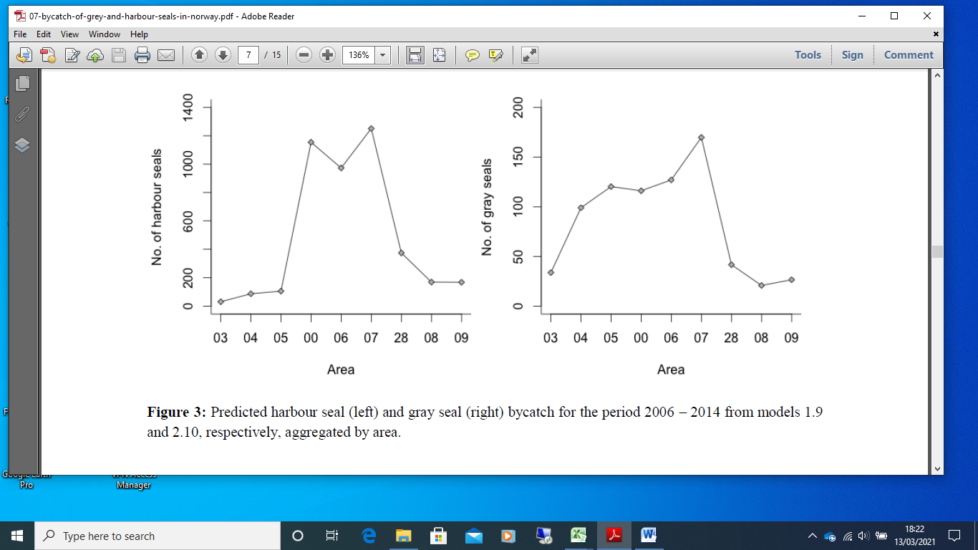

***Figure 2****. Bjørge et al. (2017) Figure 3. Harbour seal (left) and gray seal (right) bycatch over the 9 year period 2006 – 2014 from GAM models of catch rates in the Norwegian coastal gillnet fleet, aggregated by statistical area.*

***Table 1****. Digitised data from Figure 2, giving the mean annual seal bycatches by region during the 9 year period 2006-2014.*

|  |  |  |
| --- | --- | --- |
| Statistical area | Harbour seals 2006-2014 bycatch | Grey seals 2006-2014 bycatch |
| 03 | 38 | 34 |
| 04 | 88 | 102 |
| 05 | 113 | 121 |
| 00 | 1163 | 116 |
| 06 | 988 | 129 |
| 07 | 1263 | 171 |
| 28 | 388 | 43 |
| 08 | 188 | 20 |
| 09 | 175 | 27 |
| Total 2006-2014 | 4400 | 763 |
| Mean annual bycatch | 489 | 85 |
| Proportion from areas 03, 04 and 05 | 0.0540 | 0.3372 |

***Table 2****. Estimation of the mean annual bycatch weight of harbour seals in areas 03, 04 and 05. The combined bycatch weight of both species is 17.5 tonnes.*

|  |  |  |
| --- | --- | --- |
|  | Harbour seal | Grey seal |
| “All-Norway” mean annual bycatch from mark-recapture | 555 | 466 |
| Proportion from areas 03, 04, 05 from reference fleet analysis (Table 1) | 0.0540 | 0.3372 |
| Mark-recapture mean annual bycatch from areas 03, 04 , 05 | 30 | 157 |
| Mean body weight (kg) | 60 | 100 |
| Bycatch weight in areas 03, 04, 05 (tonnes) | 1.8 | 15.7 |

***Table 3****. Extrapolation of areas 03, 04, 05 pinniped annual bycatch (tonnes) to total Barents Sea. Note that only part of statistical area 5 is within the Barents Sea model domain, which accounts for the fact that Barents Sea gillnet activity is less than that in areas 3, 4, 5.*

|  |  |  |  |  |
| --- | --- | --- | --- | --- |
| Gear | 2011-2019 annual average Norwegian activity in areas 03, 04, 05 (hours fishing) | 1997-2014 annual average pinniped bycatch in areas 03, 04, 05 (tonnes) | 2011-2019 annual average international activity in the Barents Sea model domain (hours fishing) | **Barents Sea fleet total annual bycatch (tonnes)** |
| Gillnets | 94,641 | 17.5 | 33,489 | **6.2** |

**References**

Bjørge, A., Øien, N., Hartved, S., Bøthun, G. and Bekkby, T. (2002). Dispersal and bycatch mortality in gray, *Halichoerus grypus*, and harbour, *Phoca vitulina*, seals tagged at the Norwegian coast. Marine Mammal Science **18**, 963-976.

Bjørge, A., Moan, A., Nilssen, K.T. and Øigård, T.A. (2017). Bycatch of harbour and grey seals

in Norway. North Atlantic Marine Mammal Commission SC/24/BYCWG/07 By-catch WG 2-4, May 2017, 15pp. <https://nammco.no/wp-content/uploads/2017/04/07-bycatch-of-grey-and-harbour-seals-in-norway.pdf>

Moan, A, G. (2016). Bycatch of harbour porpoise, harbour seal and grey seal in Norwegian gillnet fisheries. Master thesis, University of Oslo, 73pp.